IBM Cloud services



|  |  |
| --- | --- |
| Team ID | PNT2022TMID24187 |
| Project Name | smartfarmer-IOT Enabled Smart farming Application |
| Date | 11 November 2022 |

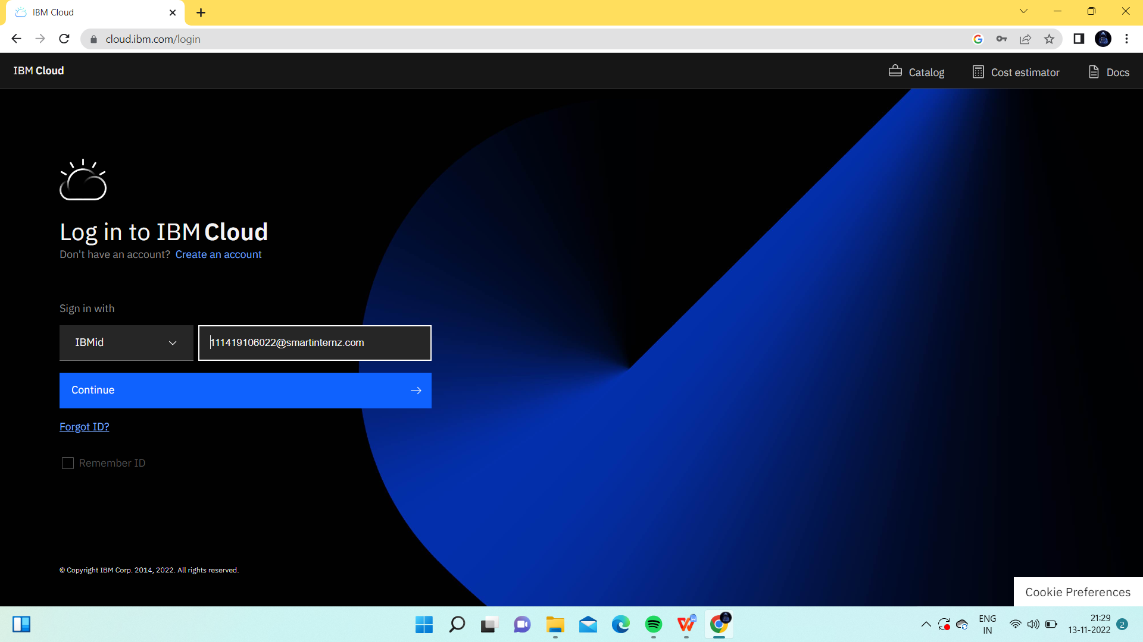

IBM Cloud services

